**A**

**REPORT**

**ON**

**INDUSTRIAL TRAINING ON**

**“Web Development”**

**Taken at**



In partial fulfilment of the requirement for the degree of

**Bachelor of Technology**

Computer Science and Engineering



Duration: From 21st March, 2023 to 29th April, 2023

Submitted to: Submitted by:

Ms. Megha Singh Shruti Sinha

This is to certify that the report of the training submitted is the outcome of the practical training done at ‘Coincent’ in ‘Web Development’ is carried out by Shruti Sinha under the guidance and supervision of “Ms. Megha Singh” for the award of Degree of **Bachelor of Technology(B.Tech.) in** Computer Science and Engineering , from Bhagalpur College of Engineering, Bhagalpur affiliated to Bihar Engineering University, Biharduring the academic year 2022-2023.

To the best of my knowledge the report:-

i .Embodies the work of the candidate .

ii. Has duly been completed.

iii. Is up to the desired standard for the purpose of which is submitted.

**ACKNOWLEDGEMENT**

Any serious and lasting achievement or success, one can never achieve without the help. guidance and co-operation of so many people involved in the work.

It is my pleasant duty to express my profound gratitude and extreme regards and thanks to Ms. Megha Singh who gave me an opportunity to take professional training in Coincent.

I am indebted towards Ms. Megha Singh who has allotted this project and his precious time and advice during the training period, which is imminent to the report.

I would like to express deep gratitude to Dr Smita Agrawal, Head of Department (Computer Science and Engineering), Raj Anwit without whose permission the training would not be possible. I would also like to thank Mr. Piyush Gautam, Training & Placement Officer, Department and Ms. Deepika Bansal, PTS Coordinator, Department of Bhagalpur College of Engineering BCE Bhagalpur, who recommended me for this training.

**SHRUTI SINHA**

**Reg No:-** 19105108009

**Company Profile**

COINCENT

**Coincent** is a manage marketplace that offers Live Industrial Training, Projects & Internship to students. We are a professional community of Industry Experts and academia, who have come together to help learners become employable. We use Design Thinking and a learner-centred approach to problem-solving and focusing on application-based learning.

Our Industrial Trainers, mentors, and counsellors are passionate tutors & student career-driven specialists in their fields with years of Industrial Expertise in eminent companies like Google, IBM, Microsoft, and more.

Besides we use our leading-edge and comprehensive Internally developed AI tools to make certain that our learners experience customized and personalized learning to achieve exponential success.

We are a bunch of individuals always working to make a difference in students’ career and to meet the needs of the industries by bridging the skill gap between colleges and industries.

**CHAPTER 1**

INTRODUCTION

**1.1 Problem Statement**

Develop an ecommerce web application which includes a home page, login and register page also there should be payment gateway page .Also all the data from each page should be stored in a google sheet.

**1.2 Project Objectives**

The purpose of this project is to get introduced to the E-commerce website by using the payment gateway method ,which can only be done in the case of E-commerce website.

Also, the web application should be responsive in nature which means this app will work

exactly same on all type of devices such as Android devices, Laptops and Tablets as well.

**This web app achieves following:-**

* Responsive framework.
* Includes payment gateway.
* Stores all the data from all the pages in google sheets.
* Interlinked webpages.
* User friendly environment.

**CHAPTER 2**

**2.2 Departments**

Development Tools and Languages

**Table 2.2**: Tools and Languages List used by me for the development of the different types of products.

|  |  |
| --- | --- |
| **No.** | **Web Technologies** |
| 1. | JavaScript(Programming Language for the web) |
| 2. | HTML5(Programming Language for the web) |
| 3. | CSS3 |
|  |  |

Database Management Systems

**Table 2.3**: List of Database Management System I used for the development of my product.

|  |  |
| --- | --- |
| **No.** | **Database Systems** |
| 1. | Google Sheets |
| 2. | API URL call for JSON data |

**2.3 Roles and Responsibilities**

We comprehend that each business is unique and their product needs are distinctive as well. Remembering that, we have manufactured administrations that can be custom fitted to meet every one of your necessities.

**CHAPTER 3**

TOOLS & TECHNOLOGIES

**3.1 The language used for Web Development**

I have used HTML5, CSS3, and JavaScript for the development of web applications.

**3.2 Editor: Visual Studio Code**

Visual Studio Code (VS Code) is a source code editorial manager created by Microsoft that can be run on Windows, macOS, and Linux. It is free, open-source, and offers help for investigating just as implicit Git variant control, linguistic structure features, scraps, etc. The UI of the VS Code is exceptionally adjustable, as chants can change to various subjects, console altern.

**3.3 Google Sheets API URL**

The Google Sheets API is a RESTful interface that lets you read and modify a spreadsheet's data. The most common uses of this API include the following tasks:

* Create spreadsheets
* Read and write spreadsheet cell values
* Update spreadsheet formatting
* Manage Connected Sheets

I used google sheet api URL in order to store all the data from the form pages which the user will be filling to collect all the data for the convenience of user as whenever user will again visit the site if logged in then the data will already be stored and there will be no need to login again.

**CHAPTER 4**

DEVELOPMENT PROCESS

**4.1 Project Design**

A good project plan and design makes any project a lot easier. Project design is an initial stage of the project, When I was taking training from Coincent, my initial work was to creating an ecommerce web application by making it fast. dynamic, and responsive and it is tough. I worked day and night to accomplish this task by using Bootstrap 5, a cutting-edge technology. In this section, we give full concern towards the use-case diagram of my internship project and that will be described in the portion of our project.

4.1.1 After completing that, we will give focus on the use case diagram and represent it in section

4.1.2 and Project functionalities in section

4.2 implementation in section

This should be the flow of our project development process.

**4.1.1 USE-CASE DIAGRAM**

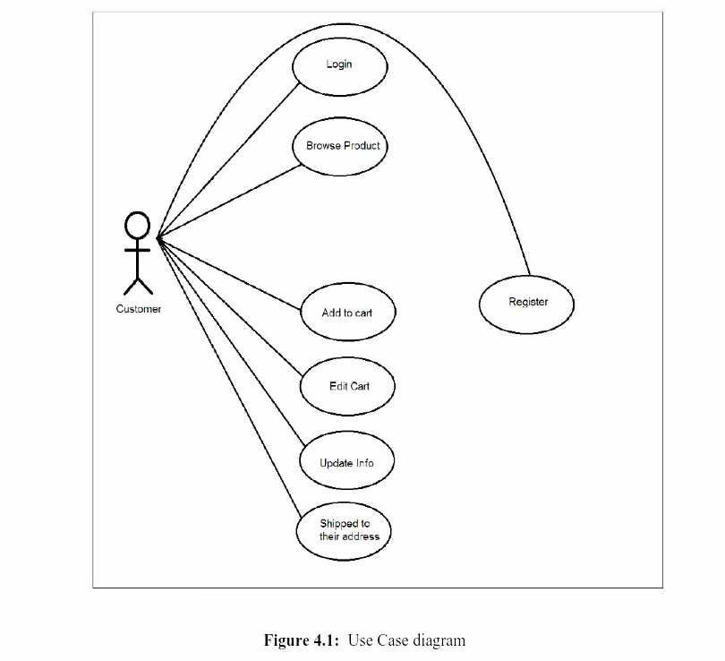

The Use Case Diagram given above shows a use case diagram is a graphic depiction of the interactions among the elements of a system. Use Case Diagram portrayed the system's functionality and necessity by using actors and use cases. It is represented by either circles or ellipses.

**4.2 Project functionalities**

i. A user can register as a new member.

ii. An existing user can log in.

iii. A user can view all products.

iv. A user can search for products by category.

v. A user can add any product to the cart.

vi. A user can order the product to its address.

**4.3 Implementation**

Figure 4.3. shows the home page of this project which is divided into two parts the header and the body.

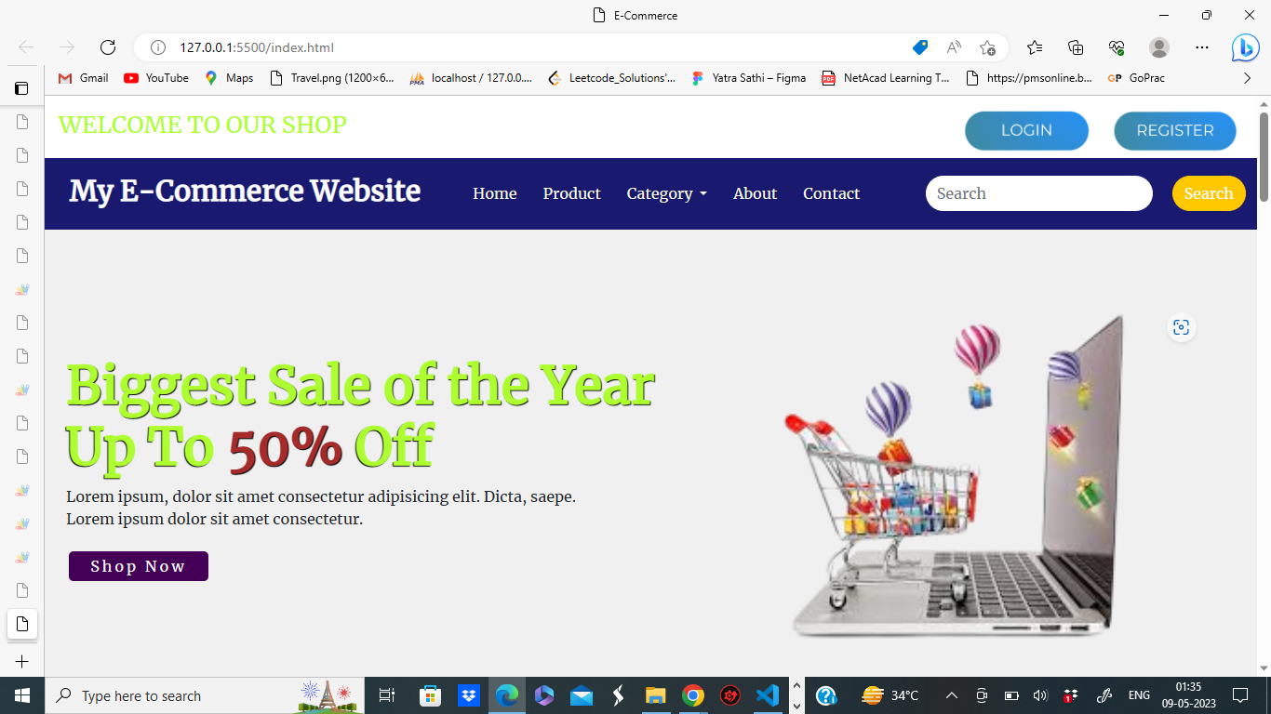



**Fig.4.3**. Home Page



**Fig 4.4**: Header of the project

The body contains the main part of the project of the project which shows the list of all products to the user can easily find their expected product and if a user clicks on any product , he will get a buy now option through he can buy the product.

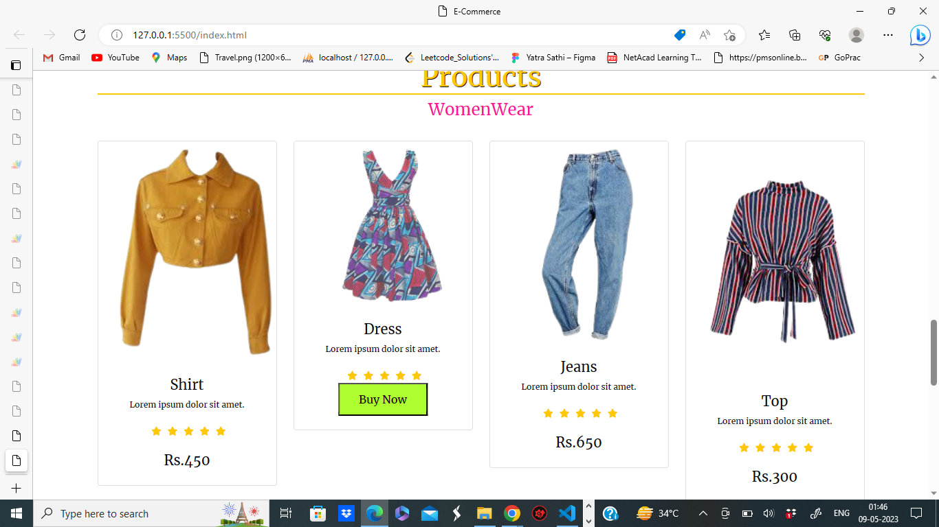

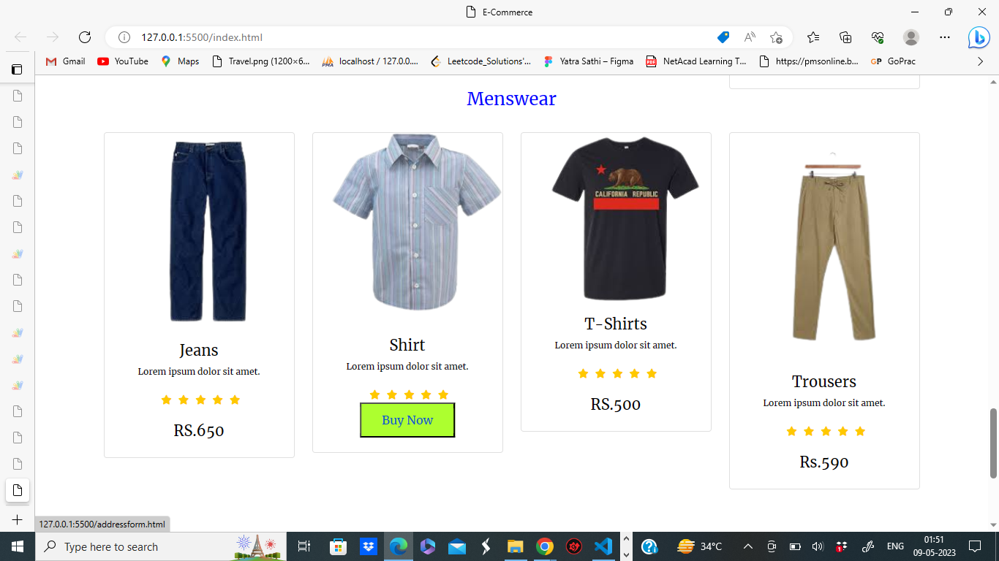

**Fig.4.4.** Products of the project

This is the user registration page of our project. If a user wants to become a member of the website, he needs to fill out the form and hit the register button after that he will become a registered member of this site.

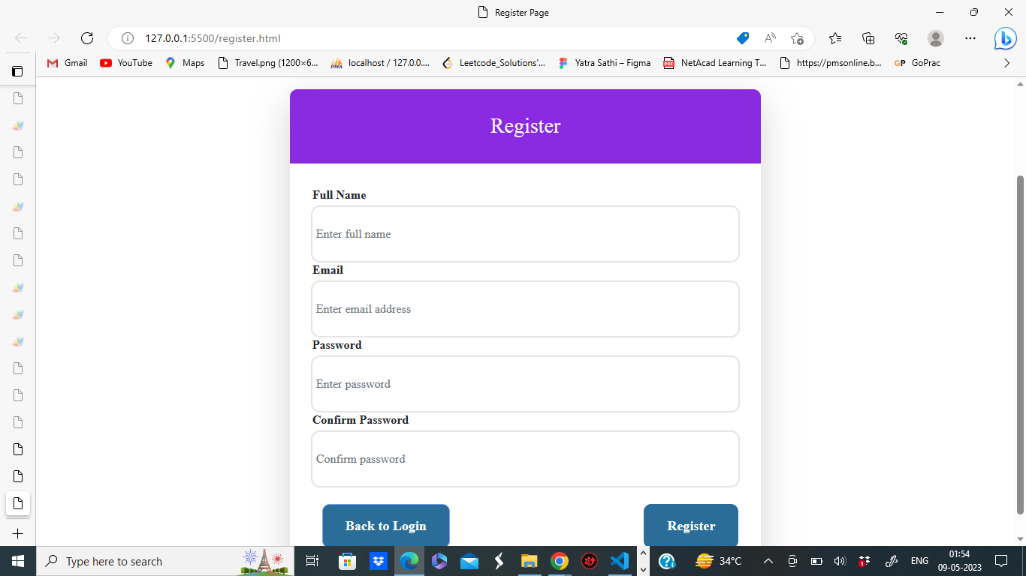

**Fig.4.13**. Registration page of the project.

**Google Sheet data for Registration page:-**

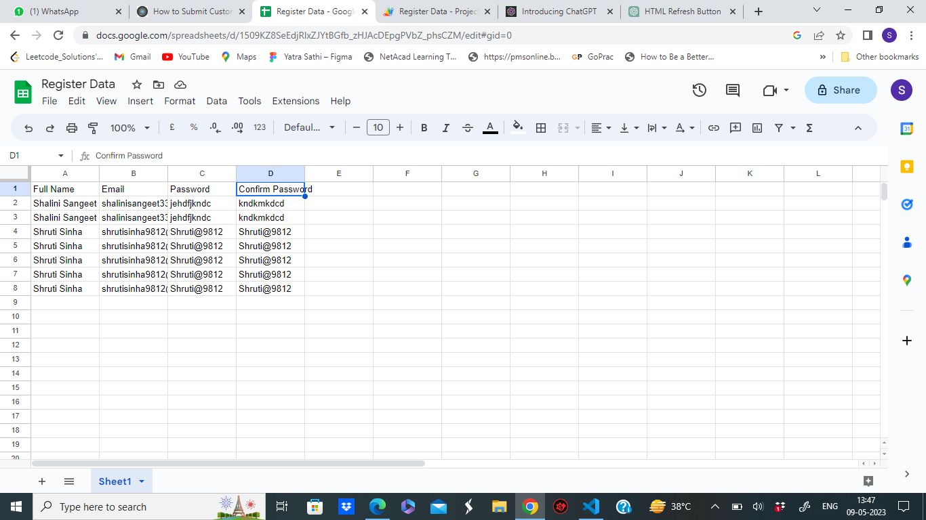

A registered member can easily log in to this site for completing the checkout process by putting his login details into the user login form.

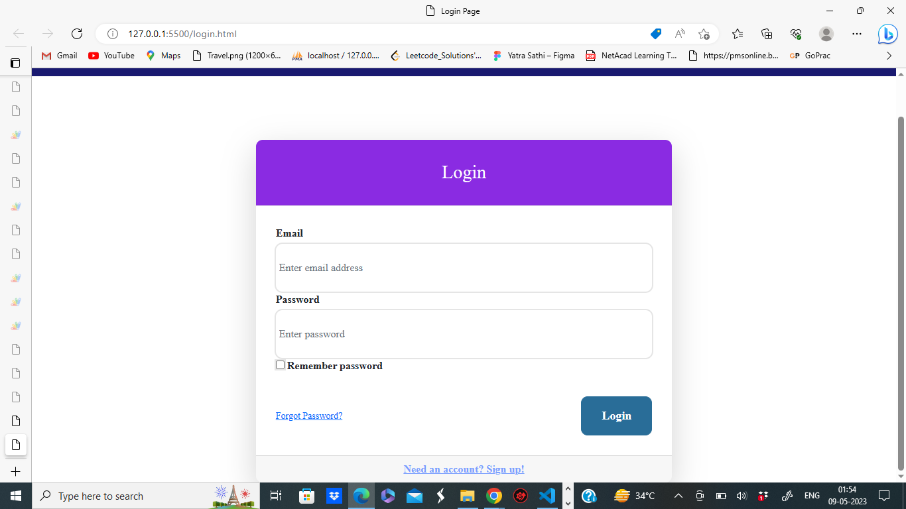

**Google sheet data for Login data:-**

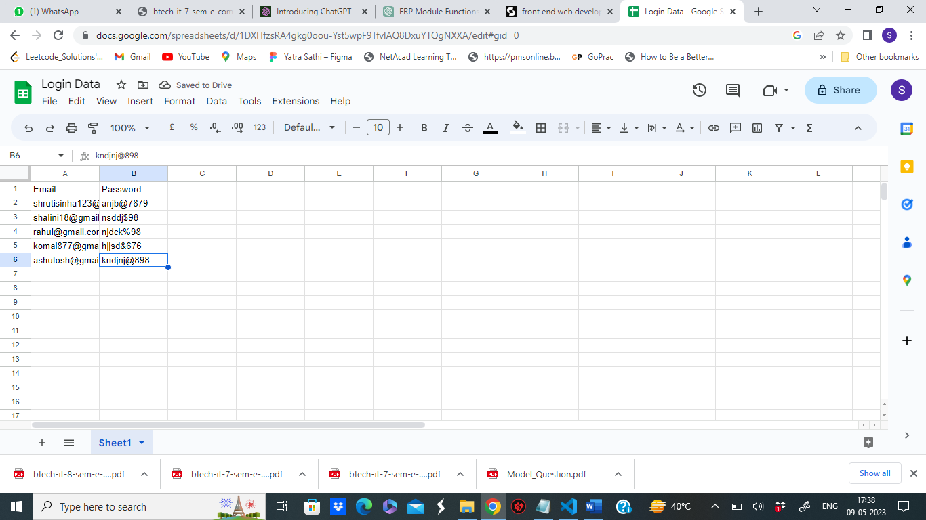

User have to add their billing address as well in order to do the payment.

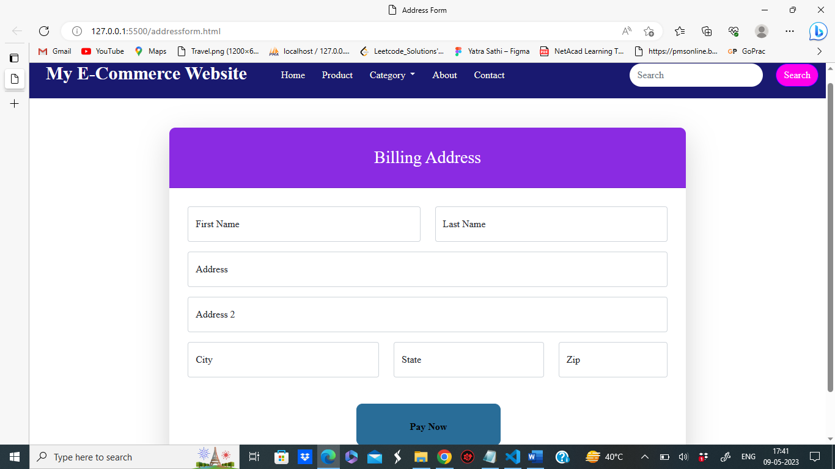

**Google sheet data for Address Data:-**

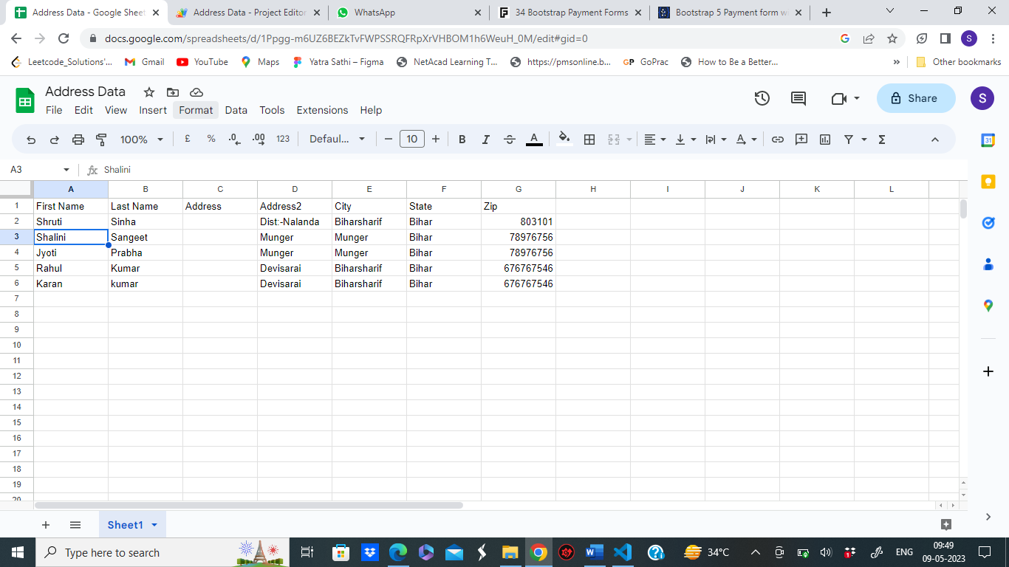

**Payment gateway page-:**

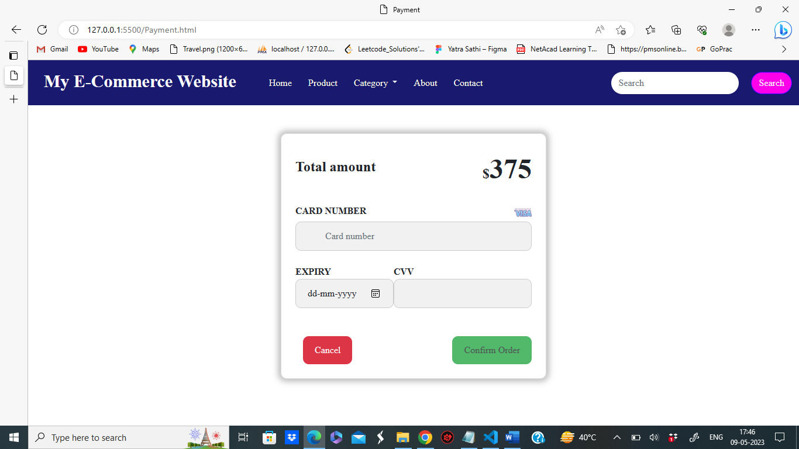

**Chapter 5**

Conclusion

The purpose and objective of this project is achieved. By providing extremely rich graphical user interface, web page designing is easy and in an aesthetic form. Flexibility in designing makes user explore their imagination and thus, even a novice user can dream and accomplish their wish of web page designing.

The training period of front end of web development was extremely effective and interactive.

Also, the problem given was the perfect for using all the skills and knowledge learned during the session. Support team was also very helpful as whenever I needed to know some information about the session and mailed , they always replied instantly.

Overall, it was a great experience for the students who have keen interest in web app development, also I am looking forward for upcoming sessions of backend web app development.